Software Requirements Specification

April 10, 2017

Cosmetic Market System

Büşra METİN

Table of Contents

1.0. Introduction 1
1.1. Purpose 1
1.2. Scope of Project 1
1.3. Glossary 2
1.4. References 2
1.5. Overview of Document 2
2.0. Overall Description 4
2.1 System Environment 4
2.2 Functional Requirements 4
2.3 Non-Functional Requirements 5
3.0. Requirements Specification 6
3.1 External Interface Requirements 6
3.2 Functional Requirements Specification 6
3.2.1 Register Customer 6
3.2.2 Ordering Cycle Length 7
3.2.3 Brief Use Cases 8
3.3 Logical Structure of the Data 9
3.3.2 Security 11

1.0. Introduction

1.1. Purpose
The purpose of this document is to present a detailed description of the Cosmetic Market System. It will explain the purpose and features of the system, the interfaces of the system, what the system will do, the constraints under which it must operate and how the system will react to external stimuli. This document is intended for both the stakeholders(customers) and the developers of the system.

1.2. Scope of Project
This software system will be a Cosmetic Market System.
From the buyer point of view; seriously avoiding the time-consuming process in terms of the buyer's customer due to the easy comparison and cataloging of products that meet certain standard specifications sought. Generally more favorable price advantage compared to retail stores. This system makes it easier to shop more freely and faster because there are no salesmen like there are in stores. It provides a shopping advantage based on personal preferences.

1.3. Glossary
Term | Definition
Database | Collection of all the information monitored by this system.
Field | A cell within a form.
Cosmetic Market System Database | The existing membership database (also CMS database).
Member | A member of the Cosmetic Market System listed in the CMS database.
Software Requirements Specification | A document that completely describes all of the functions of a proposed system and the constraints under which it must operate. For example, this document.
Stakeholder | Any person with an interest in the project who is not a developer.
User | Customer

1.4. References
IEEE. IEEE Std 830-1998 IEEE Recommended Practice for Software Requirements Specifications. IEEE Computer Society, 1998.
SRSExample-webapp, 2004.

1.5. Overview of Document
The next chapter, the Overall Description section, of this document gives an overview of the functionality of the product. It describes the informal requirements and is used to establish a context for the technical requirements specification in the next chapter.
The third chapter, Requirements Specification section, of this document is written primarily for the developers and describes in technical terms the details of the functionality of the product.
Both sections of the document describe the same software product in its entirety, but are intended for different audiences and thus use different language.

2.0. Overall Description

2.1 System Environment
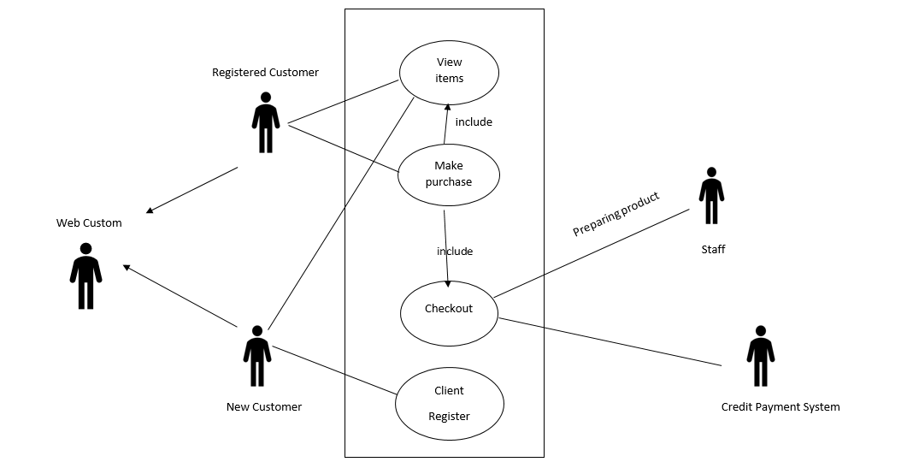
Figure 1 – Use Case Diagram

The Cosmetic Market System has 2 active actors and one cooperating system.
The Customer and System through the Internet. Any Customer communication with the system is through email. The Staff accesses the entire system directly.

2.2 Functional Requirements
Order.Basket.Add:  Order.Basket.Delete:  Order.Basket.View: | - Customer add a basket before buying the product.  - Customers drop the products they have added to the shopping list.  -Customer see his/her own shopping list.
Order.Confirm.More: | - Customer orders more than one.
Order.Deliver.Location: | - Customer can track where the order is.
Order.Product.Price.Filter:  Order.Product.Price.Details:  Order.Product.Rating:  Order.Product.Count.Details:  Order.Product.Change:  Order.Product.Return: | -Customer sort by the product price.  -Customer underbuy the system-selected products.  - Customer votes for products.  - Number of products that a customer wants to buy should be at least 1.  -Product change is not allowed.  -Product return is not allowed.
Order.Product.Search:  Order.Product.Search.Page: | - Customer search a product at the site.  - Customer switch to the desired page in a certain category.
Order.Pay.Method:  Order.Pay.Method.Details: | -Customer chooses his/her own payment option.  - A maximum of 4 installments made in payments by credit card.
Order.Place.Location: | -Customer order to different addresses.
Order.Gain.Cargo:  Order.Gain.Point:  Order.Gain.Point.Date: | -If the customer is shopping price over 100 TL, cargo is free.  - Customer earns points based on the amount of shopping he/she has made.  - The points earned by the customer are valid for 1 year.
Order.Register.Details:  Order.Register.Date: | - Customer can not have different accounts with same mail address.  - Customer’s membership duration is 6 months, password should be renewed after 6 months.

2.3 Non-Functional Requirements
1. System will be created with oracle database.
2. Java language will be used when the system is implemented.
3. Response time will be 1 ms.

3.0. Requirements Specification

3.1 External Interface Requirements
This application relies on a database to verify the membership and generate the data in the stock. Staff has the authority to control this database. The CMS Database fields of interest to the Cosmetic Market Systems are member’s name, membership (ID) number, and email address (an optional field for the CMS Database). The Ordering Cycle use case sends the Order ID to the CMS Database and a Boolean is returned denoting ordering status. The Register Customer use case requests a list of member names, membership numbers and (optional) email addresses when adding a new Customer. It returns a Boolean for membership status when updating a Customer.

3.2 Functional Requirements Specification

3.2.1 Register Customer
Use Case Name | Register Customer
Primary Actor | Customer
Precondition | Internet connection
Basic Path | - Customer wants to register.  - System asks for name, surname, email.  - Customer enters name, surname, email.  - System validates name, surname, email.  - System saves the information and display message.
Exception/ Alternative Paths | *a. System fails  1. System displays error message “System is unavailable”.  4a. System does not validate email.  - System displays error message “Invalid email.Please check your email.”.  Go to Step 2.  4b. There already exists an email account in the system.  - System displays warning message. “There is already exists an email account.”.  Go to Step 2.  4c. System does not validate name, surname.  - System displays error message. “Invalid name or surname”.  Go to Step 2.
Postcondition | Customer is registered.
Related non-functional requirement | Nothing
Frequency of Occurrence | Medium (High, Medium, Low)

3.2.2 Ordering Cycle Length
Use Case Name | Ordering Cycle Length
Primary Actor | Customer
Precondition | There exists at least 1 product in the basket.
Basic Path | 1.System asks brand name to customer.  2.Customer enters the brand name.  3.System validates brand name.  4.Customer selects any product.  5.System search the product in stock.  6.Customer determines pcs of products.  7.System validates pcs of products.  8.Customer add the products into the basket.  9.System forwards the customer to delivery information page.  10.System asks for the delivery address.  11.Customer enters the delivery address.  12.System represents total end.  13.System asks for payment information (credit card number, expiration date, security number).  14.Customer enters payment information.  15.System validates the payment information.  16.System asks to the customer for confirming the order.  17.Customer confirms the order.
Exception/ Alternative Paths | *a. System fails  1. System displays error message “System is unavailable”.  2a. System does not validate brand name  - System displays error message “Invalid brand name”.  Go to Step 1.  5a. System does not find product in stock.  - System displays warning message “The product is consumed”.  Go to Step 1.  7a. The system strikes more than the number of entries in the inventory.  - System displays warning message “Overflow in stock”.  Go to Step 6.  15a. System does not validate credit card number.  - System displays error message “Invalid credit card number”.  Go to Step 14.  15b. System does not validate expriration date.  - System displays error message “Invalid expriration date”.  Go to Step 14.  15c. System does not validate security number.  - System displays error message “Invalid security number”.  Go to Step 14.  15d. System does not find limit in the credit card.  - System displays error message “Insufficient balance”.  16a. The system did not get approval  Go to Step 1.
Postcondition | Order is accepted. Product / products are dropped from inventory.

3.2.3 Brief Use Cases

Use case: Updating Stocks
Primary Actor: Staff
Description: The staff checks the stock. Staff identified the products which are consumed. Staff is brought new products. Staff wants to update the products which are consumed in the stock. System asks information about new products. Staff enters the information of products. System saves the new products.

Use case: Cargo
Primary Actor: Staff, Customer
Description: Customer gives an order. System asks the delivery address. Customer enters the address. Staff prepares the product and sends by cargo. Customer delivers the product.

3.3 Logical Structure of the Data

The logical structure of the data to be stored in the Cosmetic Market System database is given below.
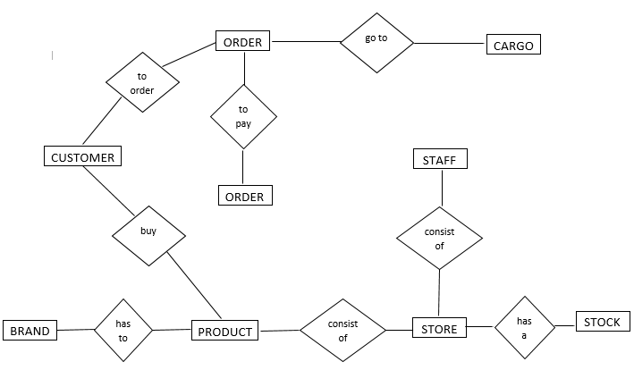

Figure 2 - Logical Structure of the Cosmetic Market System

The data descriptions of each of these data entities is as follows:

Customer Data Entity
Data Item | Type | Description | Comment
Name | Text | Name of the customer
Surname | Text | Surname of the customer
Email Address | Text | Internet address | Must be different

Product Data Entity
Data Item | Type | Description | Comment
Name | Text | Name of the product
Product ID | Integer | ID number of the product | Used as key in the product
Type | Text | Type of the product
Brand ID | Integer | Brand ID number of the product | Must be different
Price | Integer | Price of the product | May be several

Staff Data Entity
Data Item | Type | Description | Comment
Staff ID | Integer | ID number of the staff | Must be different
Name | Text | Name of the staff
Surname | Text | Surname of the staff

Order Data Entity
Data Item | Type | Description | Comment
Order ID | Integer | ID number of order
Product ID | Integer | ID number of the product | Used as key in the product

Store Data Entity
Data Item | Type | Description | Comment
Country | Text | Country of the store
Product ID | Integer | ID number of the product | Used as key in the product

Pay Data Entity
Data Item | Type | Description | Comment
Credit Card Number | Integer | Number of the customer’s credit card | Must be 16-digit
Expiration Date | Date | Expiration date of the credit card | Must be valid
Security Number | Integer | Security number of the credit card | Must be 3-digit
Limit | Integer | The limit of the customer’s credit card | Must be enough

Stock Data Entity
Data Item | Type | Description | Comment
Stock ID | Integer | ID number of the product in stock
Product ID | Integer | ID number of the product | Used as key in the product

Brand Data Entity
Data Item | Type | Description | Comment
Name | Text | Name of the product brand | May be several

Cargo Data Entity
Data Item | Type | Description | Comment
Order ID | Integer | ID number of order
Address | Text | The address of customer | Specific for customer

3.3.2 Security

The server on which the Cosmetic Market System resides will have its own security to prevent unauthorized product add/drop access. There is no restriction on product search access. The use of email by a customer is on the client systems and thus is external to the system.
The computer used by staff has its own security rights. Only the staff will have the ability to make changes to the products in stock. The credit card information of the customer will never be shared with anyone (even if it is staff) and will not be saved. Our system is not responsible for any security weaknesses that may occur on issues other than credit card information and change in stock.

